- Purpose

  - The purpose of this procedure is to provide a detailed set of instructions on how to properly collect and present a Taylor Made Sales (TMS) employee’s (EE’s) direct deposit (DD) information to the Payroll Department.

- Scope

  - The scope of this procedure encompasses steps on how to collect the DD information and how to present it to the Payroll department so that proper electronic DD funds are processed. TMS will follow the pre-noting process for all TMS new hires and EE switching of banks for DD. This process typically takes 2 payroll cycles. Sometimes the process may take less time, but HR is to instruct all EE’s of the time frames discussed above.

- Procedure

  - When a new hire is brought aboard, it will either be an External hire or an Internal hire, most likely the latter being a temp to hire situation. All EE’s must present to TMS visual evidence of their DD selection. We will NOT accept any DD information without visual documentation. EE’s will be allowed to voluntarily enroll into the DD program. Should the EE enroll into the program, then the following must occur.
    - External hires—HR will be responsible for informing all external hires of the TMS DD process. HR will be responsible for informing them if they can’t provide this upon their hire date, they will not be employed until such documentation is presented.
    - Internal hires—HR will be responsible for reminding TMS Supervisors/Managers of the DD requirement when applicants are entering the hiring process. TMS Supervisors/Managers will be responsible for ensuring that applicants have this documentation prior to them completing the new hire paperwork. Again, internal applicants will not be hired without this documentation.

  - Select the TMS DD form from the server. The applicant/EE can provide 2 types of documentation. A voided or processed check or a direct deposit bank informational form. TMS will not accept hand written bank information from the applicant / EE.

    - Screenshot below shows a valid example of a voided/sample check being used. The sample check must be taped to the top of the TMS DD form.

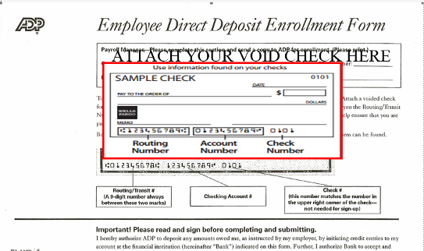

    - Screenshot below shows a valid example of acceptable documentation an applicant/EE may present in leui of a voided check. Also attached is a link to the form. TMS Direct Deposit Form

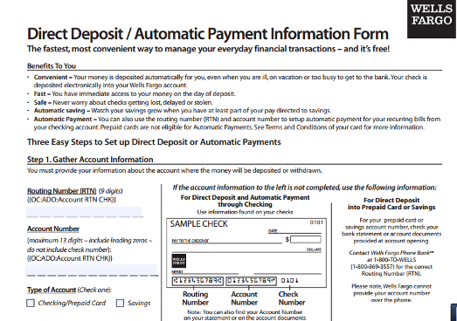
Document must be on a financial letterhead. The information in the RED CIRCLE to the right must be documented.

  - For applicant’s/ EE’s that have financial instutions such as the Money Network or Greendot, they must obtain information as outlined above. No exceptions.

  - TMS Financial Institution Partnerships.
    - TMS will reach out to local financial partners to offer applicant’s/EE’s the ability to obtain free checking accounts where ever possible.
    - These financial partnerships shall be prominently displayed in EE break areas or other high traffic EE areas at TMS locations.

